Crop Yield Prediction and Efficient use of Fertilizers
ABSTRACT:
Data Mining is an emerging research field in crop yield analysis. Yield prediction is a very important issue in agricultural. Any farmer is interested in knowing how much yield he is about to expect. Analyze the various related attributes like location, pH value from which alkalinity of the soil is determined. Along with it, percentage of nutrients like Nitrogen (N), Phosphorous (P), and Potassium (K) Location is used along with the use of third-party applications like APIs for weather and temperature, type of soil, nutrient value of the soil in that region, amount of rainfall in the region, soil composition can be determined. All these attributes of data will be analyzed train the data with various suitable machine learning algorithms for creating a model. The system comes with a model to be precise and accurate in predicting crop yield and deliver the end user with proper recommendations about required fertilizer ratio based on atmospheric and soil parameters of the land which enhance to increase the crop yield and increase farmer revenue.

ARCHITECTURE:

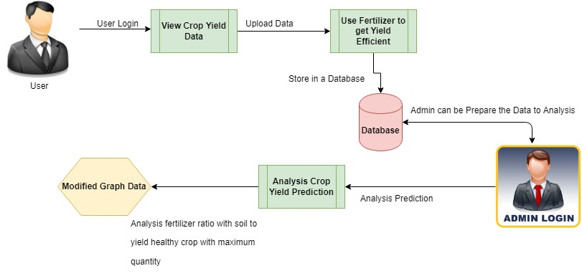
EXISTING SYSTEM:
The crop evapotranspiration is a function of both the weather and growth stage of the plant. This attribute is taken into consideration to get a good decision on the yield of the groups. They all collected the dataset with these attributes and send as input to the Bayesian network and classify into the two classes named true and false classes and compared with the observed classifications in the model with a confusion matrix and bring the accuracy.

DISADVANTAGES:

There are many ways to increase crop yield, but quality of crop is varies.

Thus, the yield prediction site, service, fertilizer, all are always prone to attack.

PROPOSED SYSTEM:
The challenge in it is to build the efficient model to predict the most efficient model to predict the output of the crop so try with the different algorithms and compare all the algorithms and which one has the less error and loss choose that model and predict the yield of that particular crop. They used various data mining techniques to predict the yield of the rice crop. Rice crop is the sustainable security of India. In general, it contributes 40% to the general yield. High yield of the crop is based on the appropriate climatic conditions. Learning a better strategy to grow the crop according to the climatic conditions can improve the crop yield. The reports utilize various mining techniques based on the previous data of the crop yield and different climatic regions. The raw data in the crop data is cleaned and the metadata is appending to it by removing the things which are converted to the integer. So, the data is easy to train. Hear all the data. In this pre-processing, we first load the metadata into this and then this metadata will be attached to the data and replace the converted data with metadata. Then this data will be moved further and remove the unwanted data in the list and it will divide the data into the train and the test data.

ADVANTAGES

Analysis the Crop yielded from soil to add the required ratio of Fertilizer to get maximum yield of crop based on climatic conditions.

High Crop Yield Production with soil prediction analysis with efficient fertilization.

MODULES:
- Upload Crop and Fertilizer Products
An important aspect of analysis of soil efficiency to predict the ratio of Fertilizer product based on climatic conditions. To find the efficiency of the crop yield, get the required input about the soil data and predict the dataset for analysis purpose.

- Crop Yield Prediction
“ Prediction” refers to the output of an algorithm after it has been trained on a historical dataset and applied to new data when you’re trying to forecast the likelihood of a particular outcome, such as whether or not a customer will churn to the climatic conditions. The algorithm will generate probable values for an unknown variable for each record in the new data, allowing the model builder to identify what that value will most likely be.
- Graphical Representations
The analyses of proposed systems are calculated based on the approvals and disapprovals. This can be measured with the help of graphical notations such as pie chart, bar chart and line chart. The data can be given in a dynamical data.

REQUIREMENT ANALYSIS
The project involved analyzing the design of few applications so as to make the application more users friendly. To do so, it was really important to keep the navigations from one screen to the other as well to order and at the same time reducing the amount of typing the user needs to do. In order to make the application more accessible, the browser version had to be chosen so that it is compatible with most of the Browsers.
REQUIREMENT SPECIFICATION
Functional Requirements
- Graphical User interface with the User.
Software Requirements
For developing the application the following are the Software Requirements:
- Python
- Django
- MySql
- MySqlclient
- WampServer 2.4
Operating Systems supported
- Windows 7
- Windows XP
- Windows 8
Technologies and Languages used to Develop
- Python
Debugger and Emulator
- Any Browser (Particularly Chrome)
Hardware Requirements
For developing the application the following are the Hardware Requirements:
- Processor: Pentium IV or higher
- RAM: 256 MB
- Space on Hard Disk: minimum 512MB

CONCLUSION
These models were experimented with different types of crops in various regions across India to predict the output. Even fertilizer data was trained using the back propagation algorithm and evaluated to get the result of how much nitrogen, phosphorus is required for the area of land. Both the models for the crop production were compared in predicting the output and by various parameters with respect to the error rate. While predicting the output for both of the models and the compassion is plotted in the graph.

